**Traffic light controller with external pedestrian crossing button**

PROJECT REPORT

FOR

**Microprocessor and Interfacing**

**Embedded Project**

WINTER SEMESTER – 2017-18

B1 SLOT

Submitted by:

Gaurav Kumar Singh – 16BCE0242

Pushan Srivastava – 16BCB0097



SCOPE

VELLORE INSTITUTE OF TECHNOLOGY

VELLORE – 632014 TAMIL NADU

INDIA

**Abstract**

After the industrial revolution number of vehicles produced has increased significantly. It is due to this fact that traffic light were introduced to the public. But however it ignored the fact that people without vehicles need to cross the roads to. So in this project our aim is to develop a traffic light controller which not only gives and extra pedestrian crossings signal controlled by the pedestrians themselves but also maximises the traffic movement. When no pedestrian is present, so there is no way a call button is pressed and pedestrian crossing signal is enabled. It is only enabled when a pedestrian pushes the call button in a limited window of time to avoid the spamming of button by public which can cause traffic jams.

**Contents**

1. Introduction………………………………………………………………………......04
   1. Motivation……………………………………………………………………….04
   2. Significance of Project…………………………………………………………..04
   3. Scope of Project…………………………………………………………………04
   4. Application…………………………………………………………………........05
2. Literature Survey……………………………………………………………………..05
   1. Existing Study…………………………………………………………………....05
      1. Patent 1………………………………………………………………...…05
      2. Patent 2…………………………………………………………………...05
   2. Gaps Identified…………………………………………………………………..06
3. Design and Implementation………………………………………………………..…06
   1. Components Required…………………………………………………………...06
      1. Hardware Components…………………………………………………...06
      2. Software Components…………………………………………………….07
   2. Circuit Diagram…………………...……………………………………………..07
   3. Implementation Details………………………………………………………….08
   4. Code……………………………………………………………………………..08
4. Test Cases with Snapshots……………………………………………………………09
   1. Case 1 – Normal Traffic………………………………………………………….09
   2. Case 2 – Pedestrian Crossing…………………………………………………….11
5. Conclusion……………………………………………………………………………12
6. References……………………………………………………………………………12

**1. Introduction**

**1.1. Motivation**

Traffic is a common thing these days. Roads are crowded with vehicles stuck in traffic jams causing delays and people are facing difficulty in crossing the roads. Traffic jams mainly occur because of people that do not follow traffic rules. One of the key traffic rule is following the traffic lights while driving on the road. Not following the traffic lights by the driver as well as pedestrians also result into accidents which further lead to even severe traffic jams. To cope up with this problem we aim to design a traffic light controller which is compatible with pedestrians as well.

**1.2. Significance of the project**

It’s no doubt that in today’s world everyone is in a hurry. In context to this pedestrian as well as people using vehicles can’t waste any time. Places where pedestrians cross the roads should have a strong synchronisation between the vehicles and the pedestrians to avoid major accidents. Marked pedestrian crossings are often found at [intersections](https://en.wikipedia.org/wiki/Junction_(road)), but may also be at other points on busy roads that would otherwise be too unsafe to cross without assistance due to vehicle numbers, speed or road widths. They are also commonly installed where large numbers of pedestrians are attempting to cross (such as in shopping areas) or where vulnerable road users (such as school children) regularly cross. Signalised pedestrian crossings clearly separate when each type of traffic (pedestrians or road vehicles) can use the crossing. Unsignalised crossings generally assist pedestrians, and usually prioritise pedestrians, depending on the locality.

Call buttons are installed at traffic lights with a dedicated pedestrian signal, and are used to bring up the pedestrian "walk" indication in locations where they function correctly. In the majority of locations where call buttons are installed, pushing the button does not light up the pedestrian walk sign immediately.

**1.3. Scope of the Project**

Using our traffic light controller with external pedestrian button, pedestrians are given the control of the traffic light to maximise the traffic efficiency. Pedestrian button is an active state will enable the pedestrian crossing sign which mill make all the vehicles stop so the pedestrians can safely cross by. It should also be noticed to avoid the pedestrian button spamming, the button should be pressed in a limited time window, so that pedestrians can’t spam the button which will make the traffic even worse. If the button is not pressed in that limited time space, normal traffic protocol will be followed.

**1.4. Application**

The only application of this project is to maximise the efficiency of the traffic with proper pedestrian crossing mechanism.

**2. Literature Survey**

**2.1. Existing Study**

**2.1.1. Patent [1]**

This invention relates to emergency traffic-light controller systems, and more particularly relates to novel improvements in remotely-controlled traffic-light systems whereby an emergency vehicle such as an ambulance or a police car can by remote means located within the vehicle control traffic lights which it is approaching so as to present a go signal along the path of the vehicle and red lights to vehicles approaching on crossing streets.

It is a principal object of this invention to provide radio control means for controlling traffic lights in which a transmitter of limited range is located within the emergency vehicle, or alternatively in a traffic-control helicopter, and in which receivers are located at each traffic light-controlled intersection, the receivers being tuned to the transmitter carrier frequency.

It is another very important object of the present invention to provide a radio frequency control system employing control signals which are coded with at least two different modulating frequencies which must both be present at the receiver in order to switch over the traffic light controller from local to remote, whereby accidental interference with the normal function of the traffic-controller which might be caused by spurious signals is virtually precluded.

**2.1.2. Patent [2]**

It is yet another object of the present invention to provide an electronic traffic signal controller which is compatible with and easily connected with a large number of auxiliary traffic and pedestrian control signal arrangements.

It is another object of the present invention to provide an electronic traffic signal controller employing a basic timing circuit which may be rendered inoperative and/or retimed by auxiliary traffic and pedestrian control apparatus connected to the basic control unit.

Another object of the present invention is to provide an electronic traffic signal controller to which a Walk- Don’t Walk control unit may readily be added by the simple expedient of connecting a single cable between the basic and the auxiliary units.

**2.2. Gaps Identified**

* The first device has not given any priority to the pedestrians, rather having all the focus on emergency vehicles.
* The second device did not solve the problem of the traffic flow when there are no pedestrians, still the pedestrian light will be enabled which wastes time of the people in vehicles.

**3. Design and Implementation**

**3.1. Components Required**

**3.1.1. Hardware Requirements**

* **LEDs (red, yellow, green, blue):** A light-emitting diode (LED) is a two-[lead](https://en.wikipedia.org/wiki/Lead_(electronics)) [semiconductor](https://en.wikipedia.org/wiki/Semiconductor) [light source](https://en.wikipedia.org/wiki/Light_source). It is a [p–n junction](https://en.wikipedia.org/wiki/P%E2%80%93n_junction) [diode](https://en.wikipedia.org/wiki/Diode) that emits light when activated.[[5]](https://en.wikipedia.org/wiki/Light-emitting_diode#cite_note-5)When a suitable [current](https://en.wikipedia.org/wiki/Electric_current) is applied to the leads,[[6]](https://en.wikipedia.org/wiki/Light-emitting_diode#cite_note-6)[[7]](https://en.wikipedia.org/wiki/Light-emitting_diode#cite_note-7) [electrons](https://en.wikipedia.org/wiki/Electron) are able to recombine with [electron holes](https://en.wikipedia.org/wiki/Electron_hole) within the device, releasing energy in the form of [photons](https://en.wikipedia.org/wiki/Photon). This effect is called [electroluminescence](https://en.wikipedia.org/wiki/Electroluminescence), and the colour of the light (corresponding to the energy of the photon) is determined by the energy [band gap](https://en.wikipedia.org/wiki/Band_gap) of the semiconductor. LEDs are typically small (less than 1 mm2) and integrated optical components may be used to shape the [radiation pattern](https://en.wikipedia.org/wiki/Radiation_pattern).
* **Breadboard:** A breadboard is a solderless device for temporary prototype with electronics and test circuit designs. Most electronic components in electronic circuits can be interconnected by inserting their leads or terminals into the holes and then making connections through wires where appropriate.
* **Resistors:** A resistor is a [passive](https://en.wikipedia.org/wiki/Passivity_(engineering)) [two-terminal](https://en.wikipedia.org/wiki/Terminal_(electronics)) [electrical component](https://en.wikipedia.org/wiki/Electronic_component) that implements [electrical resistance](https://en.wikipedia.org/wiki/Electrical_resistance) as a circuit element. In electronic circuits, resistors are used to reduce current flow, adjust signal levels, to divide voltages, [bias](https://en.wikipedia.org/wiki/Biasing) active elements, and terminate [transmission lines](https://en.wikipedia.org/wiki/Transmission_line), among other uses. High-power resistors that can dissipate many [watts](https://en.wikipedia.org/wiki/Watt) of electrical power as heat, may be used as part of motor controls, in power distribution systems, or as test loads for [generators](https://en.wikipedia.org/wiki/Electric_generator). Fixed resistors have resistances that only change slightly with temperature, time or operating voltage. Variable resistors can be used to adjust circuit elements (such as a volume control or a lamp dimmer), or as sensing devices for heat, light, humidity, force, or chemical activity.
* **Connecting wires:** Copper connecting wires of low resistance to connect various modules in the breadboard.
* **Pushbutton switch:** A simple button to either conduct or stop the flow of current through it.
* **Arduino UNO Rev3:** Arduino Uno is a microcontroller board based on the ATmega328P ([datasheet](http://www.atmel.com/Images/doc8161.pdf)). It has 14 digital input/output pins (of which 6 can be used as PWM outputs), 6 analog inputs, a 16 MHz quartz crystal, a USB connection, a power jack, an ICSP header and a reset button. It contains everything needed to support the microcontroller; simply connect it to a computer with a USB cable or power it with an AC-to-DC adapter or battery to get started.

**3.1.2. Software Requirements:**

* **Arduino Software (IDE):** The open-source Arduino Software (IDE) makes it easy to write code and upload it to the board. It runs on Windows, Mac OS X, and Linux. The environment is written in Java and based on Processing and other open-source software. This software can be used with any Arduino board.

**3.2. Circuit Diagram:**

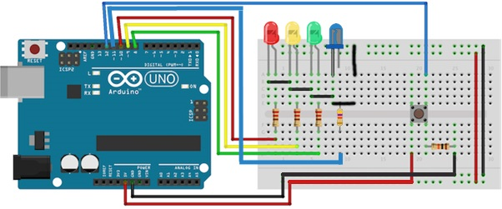

**3.3. Implementation Details**

This traffic light controller has been implemented by the help of 4 LEDs, each of which represents green, yellow, red and blue (pedestrian crossing) signals. The processing module used in this project is Arduino UNO microcontroller which checks if the pedestrian button is pushed and in high state then the traffic light should change its state to pedestrian crossing. If not, then normal protocol will be followed in which green, yellow and red signals are given in an endless loop.

**3.4. Code**

int red = 10;

int yellow = 9;

int green = 8;

int blue=11;

int button = 12;

void setup() {

pinMode(red, OUTPUT);

pinMode(yellow, OUTPUT);

pinMode(green, OUTPUT);

pinMode(blue, OUTPUT);

pinMode(button, INPUT);

}

void loop(){

digitalWrite(blue, LOW);

changeLights();

}

void changeLights(){

// turn off red and yellow, then turn on green

digitalWrite(yellow, LOW);

digitalWrite(red, LOW);

digitalWrite(green, HIGH);

delay(10000);

// green off, yellow on for 3 seconds

digitalWrite(green, LOW);

digitalWrite(yellow, HIGH);

digitalWrite(red, LOW);

delay(5000);

// turn off yellow, then turn red on for 5 seconds

digitalWrite(yellow, LOW);

digitalWrite(red, HIGH);

digitalWrite(green, LOW);

delay(10000);

if (digitalRead(button) == HIGH){

delay(15); // software debounce

if (digitalRead(button) == HIGH) {

// if the switch is HIGH, ie. pushed down - change the lights!

changeLights2();

}

}

digitalWrite(green, LOW);

digitalWrite(yellow, HIGH);

delay(5000);

reset();

}

void changeLights2(){

reset();

digitalWrite(yellow, LOW);

digitalWrite(red, HIGH);

digitalWrite(blue, HIGH);

delay(10000);

reset();

digitalWrite(yellow, HIGH);

delay(5000);

reset();

}

void reset(){

digitalWrite(yellow, LOW);

digitalWrite(red, LOW);

digitalWrite(green, LOW);

digitalWrite(blue, LOW);

}

**4. Test Cases with Snapshots**

**4.1. Case 1 – Normal Traffic**

The traffic light follows normal traffic protocol which is green light then yellow light and finally red light and then yellow light. Then this loop goes on. The following are the snapshots of the normal traffic:

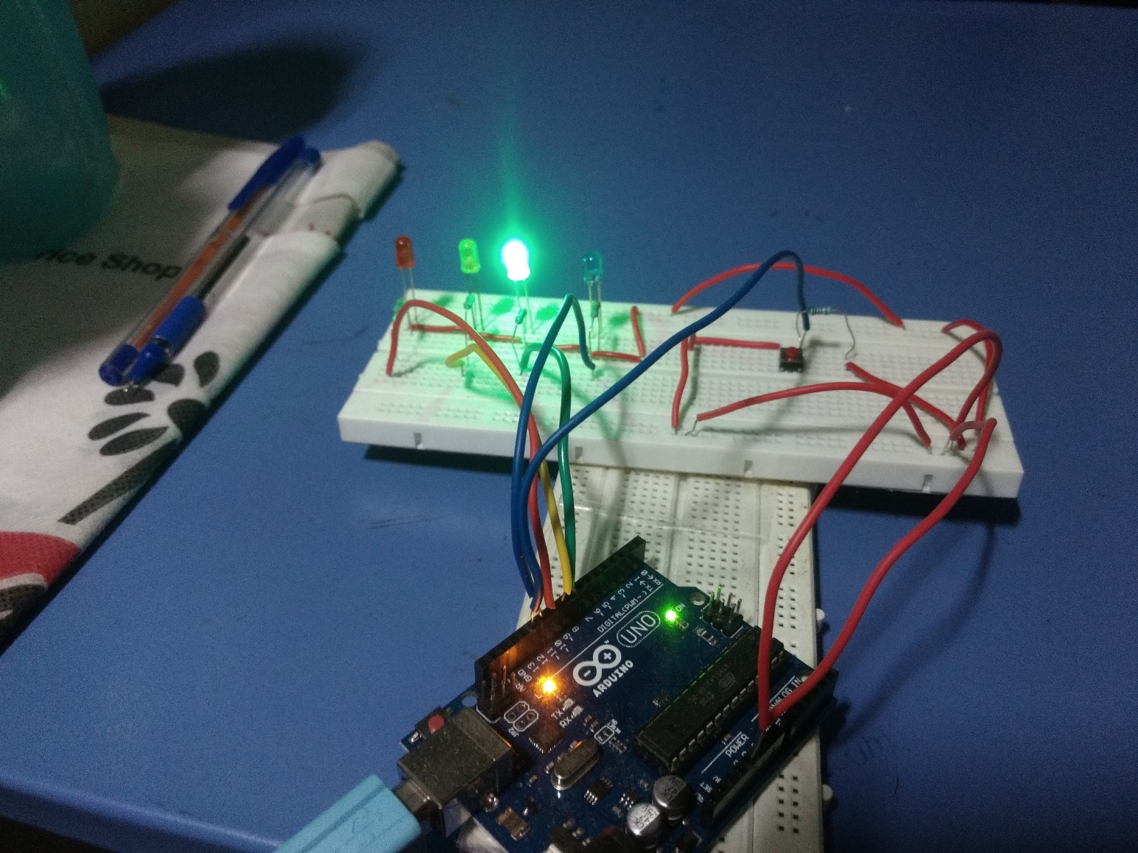

Green light on: Traffic can move

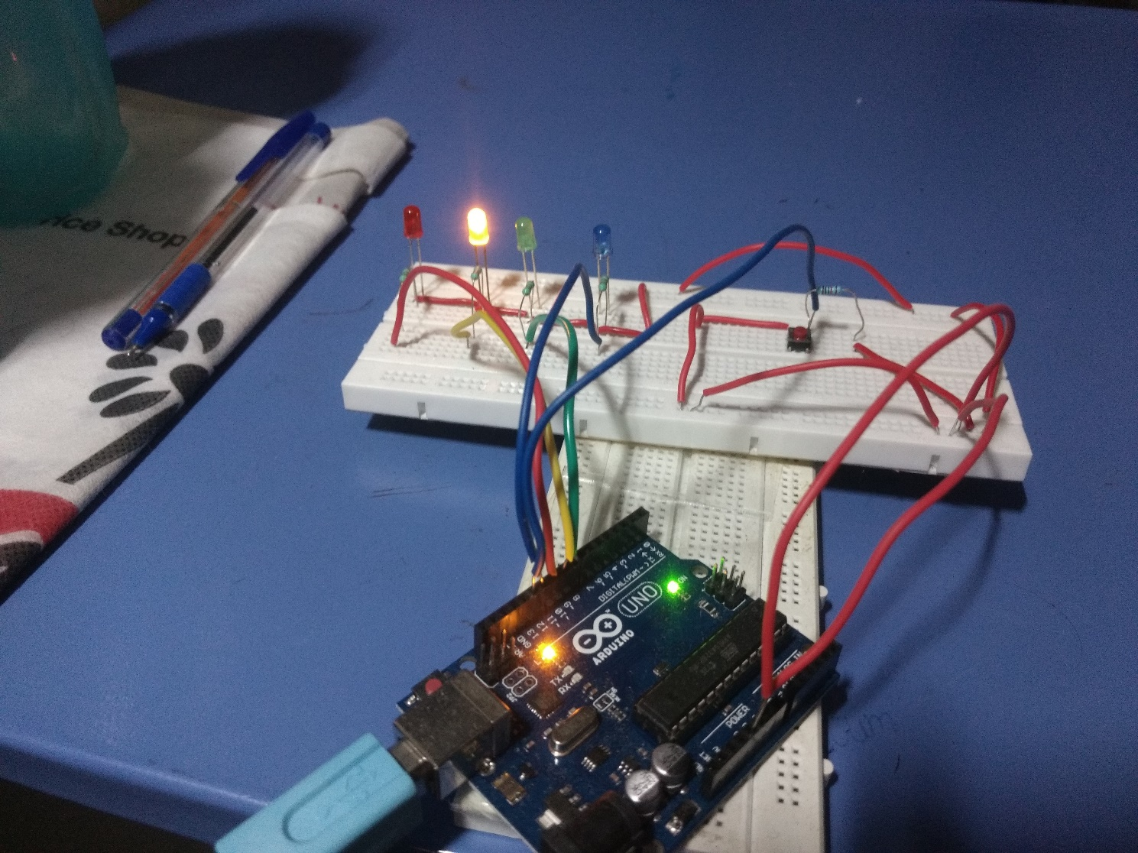

Yellow light on: Cars get ready to stop

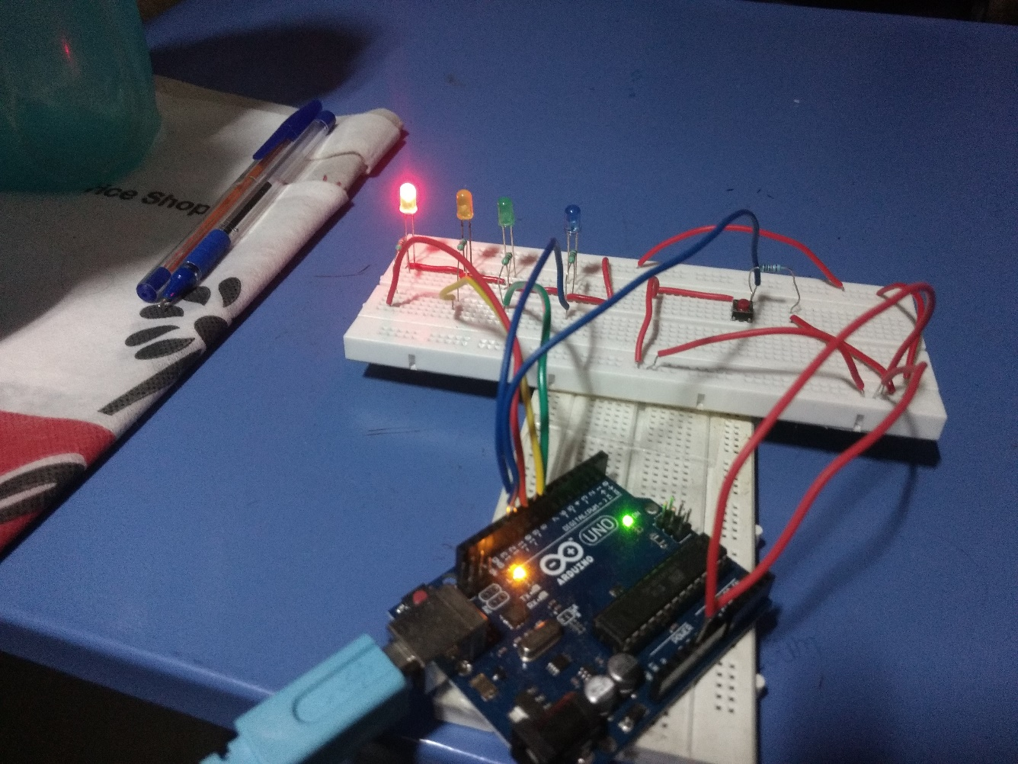

Red light on: Traffic stops

**4.2. Case 2 – Pedestrian Crossing**

The blue and red light will be enabled which will tell the vehicles to stop so that pedestrian crossing can be achieved. The following snapshot is the pedestrian crossing state of the traffic light:

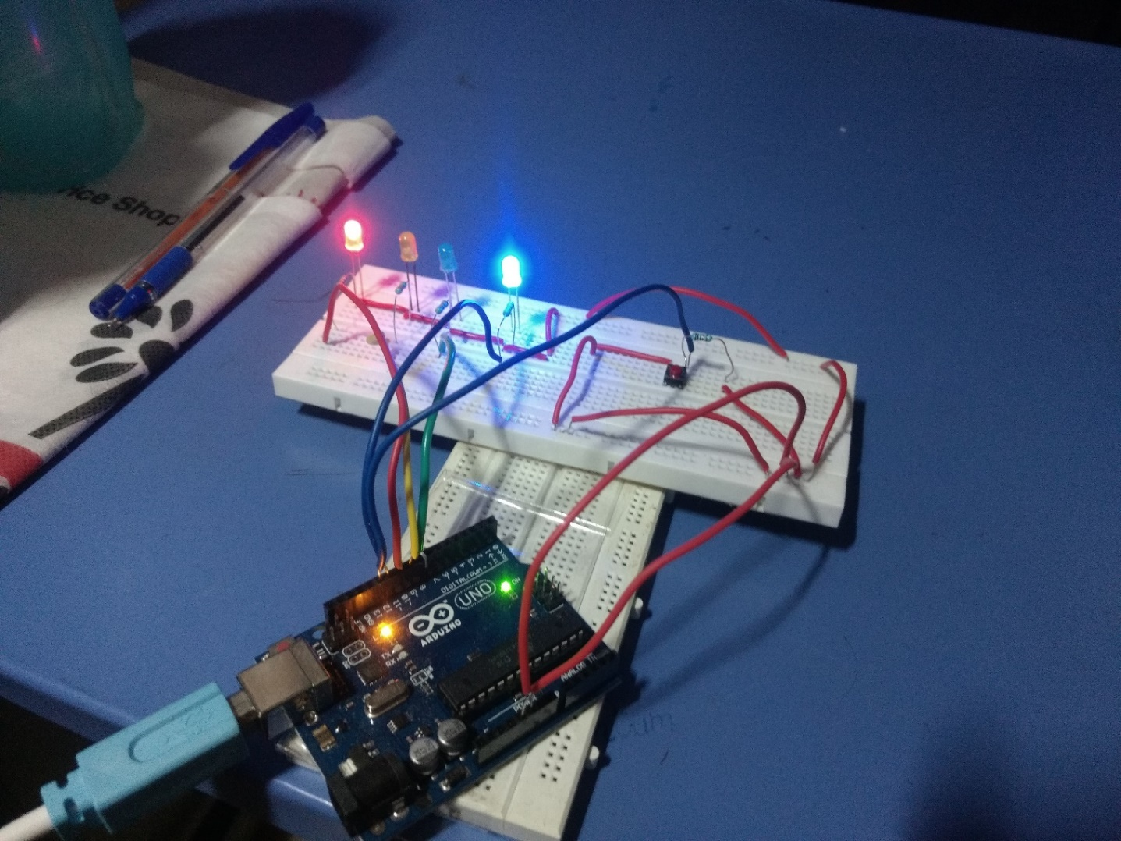

Red and Blue Light On: Traffic is stopped and pedestrians can cross

**5. Conclusion**

This project will help in dealing with the traffic problem and try to emulate and improvise the current traffic system by adding new functionalities to the existing system.

**6. References**

1. “Traffic light controller” patent by James E Ramsey, publication no. - US3114127 A
2. “Traffic light controller” patent by John C Lesher, publication no. - US3255433A
3. https://www.arduino.cc/en/Main/Software
4. https://store.arduino.cc/usa/arduino-uno-rev3
5. https://en.wikipedia.org/wiki/Resistor
6. https://en.wikipedia.org/wiki/Light-emitting_diode
7. https://en.wikipedia.org/wiki/Pedestrian_crossing#Call_buttons
8. http://wiring.org.co/learning/tutorials/breadboard/